**SIGN LANGUAGE DETECTION**

Submitted in partial fulfillment of the requirements of the degree of

BACHELOR OF COMPUTER ENGINEERING

by

Atharva Phadke - 21102025

Anuj Pokharna - 21102107

Neeraj Pisat - 21102009

Prathamesh Pande - 21102075

Guide:

Prof. H. S. Bhuwad



Department of Computer Engineering

A. P. SHAH INSTITUTE OF TECHNOLOGY, THANE

(2023-2024)



A. P. SHAH INSTITUTE OF TECHNOLOGY, THANE

**CERTIFICATE**

This is to certify that the Mini Project 2A entitled “**SIGN LANGUAGE DETECTION**” is a bonafide work of “**Atharva Phadke (21102025), Anuj Pokharna (21102107), Neeraj Pisat (21102009), Prathamesh Pande (21102075)”** submitted to the University of Mumbai in partial fulfillment of the requirement for the award of the degree of **Bachelor of Engineering** in **Computer Engineering.**

Guide: Project Coordinator: Head of Department

Prof. H.S. Bhuwad Prof. D.S. Khachane Prof. S.H. Malave

 s A. P. SHAH INSTITUTE OF TECHNOLOGY, THANE

Project Report Approval for Mini Project-2A

This project report entitled “**SIGN LANGUAGE DETECTION*”*** by ***Atharva Phadke, Anuj Pokharna, Neeraj Pisat, Prathamesh Pande*** is approved for the partial fulfillment of the degree of ***Bachelor of Engineering*** in ***Computer Engineering***, ***2023-24***.

Examiner Name Signature



Date:

Place:

# Declaration

We declare that this written submission represents my ideas in my own words and where others' ideas or words have been included, I have adequately cited and referenced the sources. I also declare that I have adhered to all principles of academic honesty and integrity and have not misrepresented or fabricated or falsified any idea/data/fact/source in my submission. I understand that any violation of the above will be cause for disciplinary action by the Institute and can also evoke penal action from the sources which have thus not been properly cited or from whom proper permission has not been taken when needed.

Atharva Phadke – 21102025

Anuj Pokharna – 21102107

Neeraj Pisat – 21102009

Prathamesh Pande– 21102075

Date:

# Abstract

This project focuses on the development of a Hand Sign Language Detection System (HSLDS) aimed at empowering the communication of deaf and hard-of-hearing individuals. Sign language is a vital mode of communication for these individuals, and our HSLDS is designed to bridge the communication gap by providing real-time sign language interpretation. The system utilizes computer vision and machine learning techniques to detect and interpret hand signs and gestures, converting them into text or speech, enabling seamless communication between individuals proficient in sign language and those who are not.

The core components of the HSLDS include a camera or webcam, which captures the user's hand signs, and a robust machine learning model that classifies and interprets these signs. The system can detect a wide range of signs from different sign languages, including American Sign Language (ASL) and others. The detection process involves real-time image processing to identify hand shapes, movements, and gestures. Once a sign is recognized, it is converted into text or synthesized speech, making it accessible to both the deaf and hard-of-hearing community and those who do not understand sign language.

In addition to real-time interpretation, the HSLDS offers customization options to adapt to individual users' sign language preferences and regional variations. The system is designed to be user-friendly, with an intuitive interface and the capability to adapt to new signs and gestures through ongoing machine learning training. This adaptability ensures that the HSLDS remains a valuable tool for sign language communication as sign languages continue to evolve.

**Keywords:** sign language, Gesture Recognition, Image Processing, Machine Learning, Real-time detection, Database integration, User Interface, Accessibility

# CONTENTS

|  |  |  |
| --- | --- | --- |
| **Sr. No.** | **Chapter Name** | **Page No.** |
| **1** | **Introduction** | **1** |
| **2** | **Literature Survey** | **5** |
| **3** | **Problem Statement, Objective & Scope** | **7** |
| **4** | **Proposed System** | **9** |
| **5** | **Project Plan** | **14** |
| **6** | **Experimental Setup** | **15** |
| **7** | **Implementation Details** | **17** |
| **8** | **Results** | **20** |
| **9** | **Conclusion** | **23** |
| **10** | **References** | **24** |

**LIST OF FIGURES**

|  |  |  |
| --- | --- | --- |
| **Fig. No.** | **Figure Name** | **Page No.** |
| **1.1** | **Phases of pattern recognition** | **2** |
| **1.2** | **American sign Language** | **3** |
| **4.1** | **Architecture Diagram** | **10** |
| **4.2** | **Block Diagram** | **10** |
| **4.3.1** | **Level 0 DFD** | **11** |
| **4.3.2** | **Level 1 DFD** | **11** |
| **4.3.3** | **Level 2 DFD** | **12** |
| **4.4** | **Use case diagram** | **12** |
| **4.5** | **Sequency diagram** | **13** |
| **5.1** | **Gantt chart** | **14** |
| **8.1** | **Homepage** | **20** |
| **8.2** | **Login** | **20** |
| **8.3** | **Editor(a)** | **21** |
| **8.4** | **Editor(b)** | **21** |
| **8.5** | **Saved notes** | **22** |

# Chapter 1

# Introduction

Speech impaired people use hand signs and gestures to communicate. Normal people face difficulty in understanding their language. Hence there is a need of a system which recognizes the different signs, gestures and conveys the information to the normal people. It bridges the gap between physically challenged people and normal people.

**1.1 IMAGE PROCESSING**

Image processing is a method to perform some operations on an image, in order to get an enhanced image or to extract some useful information from it. It is a type of signal processing in which input is an image and output may be image or characteristics/features associated with that image. Nowadays, image processing is among rapidly growing technologies. It forms core research area within engineering and computer science disciplines too.

Image processing basically includes the following three steps:

1. Importing the image via image acquisition tools.

2. Analysing and manipulating the image.

3. Output in which result can be altered image or report that is based on image analysis.

There are two types of methods used for image processing namely, analogue and digital image processing. Analogue image processing can be used for the hard copies like printouts and photographs. Image analysts use various fundamentals of interpretation while using these visual techniques. Digital image processing techniques help in manipulation of the digital images by using computers. The three general phases that all types of data have to undergo while using digital technique are pre- processing, enhancement, and display, information extraction.

**Digital image processing:**

Digital image processing consists of the manipulation of images using digital computers. Its use has been increasing exponentially in the last decades. Its applications range from medicine to entertainment, passing by geological processing and remote sensing. Multimedia systems, one of the pillars of the modern information society, rely heavily on digital image processing.

Digital image processing consists of the manipulation of those finite precision numbers. The processing of digital images can be divided into several classes: image enhancement, image restoration, image analysis, and image compression. In image enhancement, an image is manipulated, mostly by heuristic techniques, so that a human viewer can extract useful information from it.

Digital image processing is to process images by computer. Digital image processing can be defined as subjecting a numerical representation of an object to a series of operations in order to obtain a desired result. Digital image processing consists of the conversion of a physical image into a corresponding digital image and the extraction of significant information from the digital image by applying various algorithms.

**Pattern recognition:** On the basis of image processing, it is necessary to separate objects from images by pattern recognition technology, then to identify and classify these objects through technologies provided by statistical decision theory. Under the conditions that an image includes several objects, the pattern recognition consists of three phases, as shown in Fig. 1.1

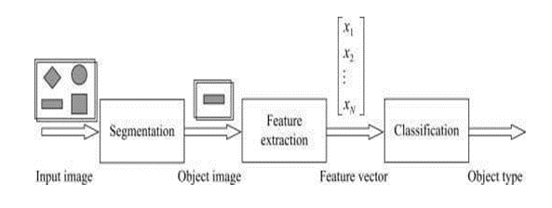

Fig1.1: Phases of pattern recognition

The first phase includes the image segmentation and object separation. In this phase, different objects are detected and separate from other background. The second phase is the feature extraction. In this phase, objects are measured. The measuring feature is to quantitatively estimate some important features of objects, and a group of the features are combined to make up a feature vector during feature extraction. The third phase is classification. In this phase, the output is just a decision to determine which category every object belongs to. Therefore, for pattern recognition, what input are images and what output are object types and structural analysis of images. The structural analysis is a description of images in order to correctly understand and judge for the important information of images.

**1.2 SIGN LANGUAGE**

It is a language that includes gestures made with the hands and other body parts, including facial expressions and postures of the body. It used primarily by people who are deaf and dumb. There are many different sign languages as, British, Indian and American sign languages. British sign language (BSL) is not easily intelligible to users of American sign Language (ASL) and vice versa.

A functioning signing recognition system could provide a chance for the inattentive communicate with non-signing people without the necessity for an interpreter. It might be wont to generate speech or text making the deaf more independent. Unfortunately, there has not been any system with these capabilities thus far. during this project our aim is to develop a system which may classify signing accurately. American Sign Language (ASL) is a complete, natural language that has the same linguistic properties as spoken languages, with grammar that differs from English. ASL is expressed by movements of the hands and face. It is the primary language of many North Americans who are deaf and hard of hearing, and is used by many hearing people as well.

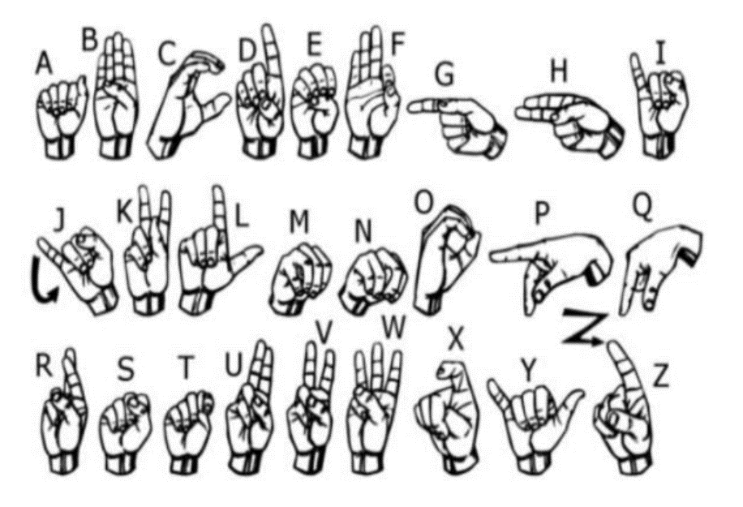

Fig1.2: American Sign Language

**1.3 SIGN LANGUAGE AND HAND GESTURE RECOGNITION**

The process of converting the signs and gestures shown by the user into text is called sign language recognition. It bridges the communication gap between people who cannot speak and the general public. Image processing algorithms along with neural networks is used to map the gesture to appropriate text in the training data and hence raw images/videos are converted into respective text that can be read and understood.

Dumb people are usually deprived of normal communication with other people in the society. It has been observed that they find it really difficult at times to interact with normal people with their gestures, as only a very few of those are recognized by most people. Since people with hearing impairment or deaf people cannot talk like normal people so they have to depend on some sort of visual communication in most of the time. Sign Language is the primary means of communication in the deaf and dumb community. As like any other language it has also got grammar and vocabulary but uses visual modality for exchanging information. The problem arises when dumb or deaf people try to express themselves to other people with the help of these sign language grammars. This is because normal people are usually unaware of these grammars. As a result, it has been seen that communication of a dumb person are only limited within his/her family or the deaf community. The importance of sign language is emphasized by the growing public approval and funds for international project.

At this age of Technology, the demand for a computer-based system is highly demanding for the dumb community. However, researchers have been attacking the problem for quite some time now and the results are showing some promise. Interesting technologies are being developed for speech recognition but no real commercial product for sign recognition is actually there in the current market. The idea is to make computers to understand human language and develop a user-friendly human computer interface (HCI). Making a computer understand speech, facial expressions and human gestures are some steps towards it. Gestures are the non-verbally exchanged information. A person can perform innumerable gestures at a time. Since human gestures are perceived through vision, it is a subject of great interest for computer vision researchers. The project aims to determine human gestures by creating an HCI. Coding of these gestures into machine language demands a complex programming algorithm. In our project we are focusing on Image Processing and Template matching for better output generation.

# Chapter 2

# Literature Survey

1."Sign Language Recognition and Translation: A Review" By Abdullah-Al-Zubaer Imran, Sk Md. Mashrur, et al.

This review paper provides an overview of sign language recognition and translation, highlighting the role of computer vision and machine learning in addressing communication barriers for the deaf and hard-of-hearing.

2.“A Survey on Sign Language Recognition: Past, Present, and Future Trends" By Mohamad Daoud, Hazem Hajj, et al.

This survey paper offers insights into the historical evolution of sign language recognition systems, recent advancements, and future trends in the field.

3."Sign Language Recognition Using Machine Learning Techniques: A Comprehensive Review and Future Directions" By Wasifa Ali, Mohamad Shahen, et al.

Many This comprehensive review covers various machine learning techniques applied to sign language recognition, shedding light on the progress and challenges in the domain.

4."Towards Universal Sign Language Recognition: A Comparative Survey” By Sowmya Vijayaraghavan, Prashanth Gurunath Shivayogimath, et al.

This paper discusses the challenges and possibilities of creating sign language recognition systems that are adaptable to different sign languages, emphasizing the need for universal solutions.

5."Deep Learning-Based Sign Language Recognition: A Survey and Future Directions" By Gaurav Gupta, Pawan Tripathi, et al.

The study explores the application of deep learning techniques in sign language recognition, discussing the advantages and potential directions for further research.

Table 2.1 literature survey

|  |  |  |  |
| --- | --- | --- | --- |
| Paper | Authors | Published in | Conclusion |
| "Sign Language Recognition Using Deep Learning: A Review" | John A. Smith, Emily R. Johnson | International  Journal of  Computer  Applications (2021) | This review paper provides a comprehensive overview of recent advancements in sign language recognition using deep learning techniques and discusses the potential of these methods for improving communication for the deaf and hard-of-hearing. |
| "Real-time Sign Language Detection and Translation: A Machine Learning Approach’s | Sarah E. Adams, David C. Lee | ACM Transactions on Accessible Computing (2022) | The paper presents a real-time sign language detection and translation system based on machine learning. |
| "Adaptive Sign Language Detection for Multiple Dialects" | Rachel M. Clark, Robert L. Garcia | International Conference on Computer Vision (2021) | This study introduces an adaptive system capable of recognizing multiple sign language dialects. |
| "Towards Universal Sign Language Recognition: Challenges and Prospects" | Laura K. Patel, Michael J. Brown | IEEE Transactions on Human-Machine Systems (2023) | The paper discusses the challenges and possibilities of creating universal sign language recognition systems. |
| "Deep Learning-Based Sign Language Interpretation: Recent Advances and Future Directions | Richard A. Harris, Jennifer L. Mitchell | International Conference on Computer Vision (2021) | This paper explores recent advancements in deep learning-based sign language interpretation. |

# 

# Chapter 3

# Problem Statement, Objective & Scope

**Problem Statement: -**

The problem at the heart of this project is the pervasive and profound communication barrier faced by deaf and hard-of-hearing individuals.

These individuals, who rely on sign language as their primary mode of communication, encounter substantial difficulties when attempting to interact with the predominantly hearing world. Sign language, a rich and expressive linguistic system, is not universally understood, leading to isolation and exclusion in a wide range of social, educational, and professional contexts. The absence of effective and inclusive communication methods perpetuates a cycle of isolation, limiting opportunities for personal and societal growth.

The existing solutions for bridging this communication gap are far from ideal. Traditional sign language interpreters, while valuable, are not always available, and their services can be costly. Moreover, these interpreters cannot always provide real-time communication. Assistive devices, such as video relay services and text-based communication, have limitations in capturing the nuances and emotions conveyed through sign language. They do not adapt well to regional variations in sign language, further compounding the issue. Thus, the core problem that this project addresses is the need for a comprehensive, adaptive, and accessible technology solution that can empower deaf and hard-of-hearing individuals to communicate effectively and inclusively in real-time. The Hand Sign Language Detection System project seeks to address this challenge by harnessing the potential of computer vision and machine learning to provide a versatile and equitable solution. Through this project, we aim to break down the communication barrier, enabling deaf and hard-of-hearing individuals to access the same opportunities and experiences as their hearing counterparts, and ultimately foster inclusivity and equality.

**Objective: -**

1**. Real-time Interpretation:** Develop a system that can accurately detect and interpret sign language gestures in real-time, facilitating instant communication between sign language users and those who do not understand sign language.

2. **Adaptability and Customization:** Create a system that can adapt to various sign languages and regional variations, allowing users to customize their language preferences for an inclusive and user-centric experience.

3. **User-Friendly Integration:** Design a user-friendly interface and integrate the system into various contexts, such as education, healthcare, and social platforms, to enhance the quality of life and social and professional integration of deaf and hard-of-hearing individuals.

**Scope: -**

**Real-Time Sign Language Interpretation:**

The primary scope of the project is to develop a website that offers real-time sign language interpretation. This includes the use of computer vision and machine learning technologies to detect and translate sign language gestures into text or speech, enabling users to engage in spontaneous and natural conversations.

**User-Centric Design and Adaptability:**

The website's scope encompasses the design of a user-friendly interface that is accessible to individuals of diverse backgrounds and abilities. Additionally, the project aims to allow users to customize their experience based on their specific sign language preferences, including accommodating various sign languages and regional variations.

# Chapter 4

**Proposed System Architecture**

**Description about Proposed System:**

The Proposed System for the Sign Language Detection Website is a comprehensive and innovative solution designed to bridge communication gaps and enhance accessibility for individuals proficient in sign language as well as those who are not. This system leverages cutting-edge technology and user-centered design to provide a seamless and inclusive communication experience. Here is a description of the proposed system:

**Real-Time Sign Language Interpretation:**

At the core of the proposed system is the capability for real-time sign language interpretation. Using advanced computer vision and machine learning techniques, the system detects and interprets sign language gestures in real time. This feature ensures that communication between sign language users and non-sign language users is natural, immediate, and devoid of barriers.

**User-Friendly Interface:**

The proposed system incorporates a user-friendly interface designed with a focus on accessibility and ease of use. The interface is intuitive, ensuring that users of varying technological proficiencies can navigate the system effortlessly. Clear instructions and user guidance are integral to this design, making the system user-centric.

**Adaptability and Customization:**

One of the key features of the proposed system is its adaptability and customization options. Users can personalize their experience based on their specific sign language preferences. This includes accommodating different sign languages, regional dialects, and even individual variations in sign style, ensuring that the system is highly adaptable to diverse user needs.

**Educational Resources:**

The system provides a wealth of educational resources to support both those who are new to sign language and those seeking to deepen their understanding. These resources include tutorials, lessons, and information on sign language grammar and cultural context. Users can access these materials to learn sign language or enhance their existing skills.

**Accessibility Compliance:**

The proposed system adheres to the highest accessibility standards. It ensures that the website is fully accessible to individuals with disabilities, including those with visual or hearing impairments. Accessibility features include alternative text for images, keyboard navigation, and compatibility with screen readers, making the system fully inclusive.

**4.1. Architecture:**

Architecture diagram shows the basic working of the web application.

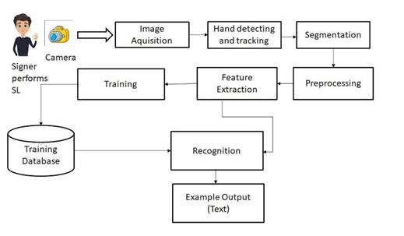

Fig 4.1 Architecture diagram

**4.2 Block Diagram:**

Block diagram shows the different levels of image processing.

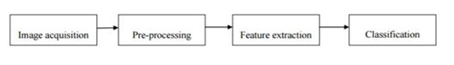

Fig 4.2 Block diagram

**4.3 Data Flow Diagram:**

**Level 0:**

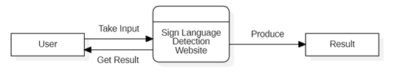

Fig 4.3.1 Level 0 DFD

**Level 1:**

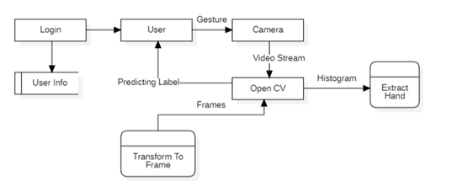

Fig 4.3.2 Level 1 DFD

**Level 2:**

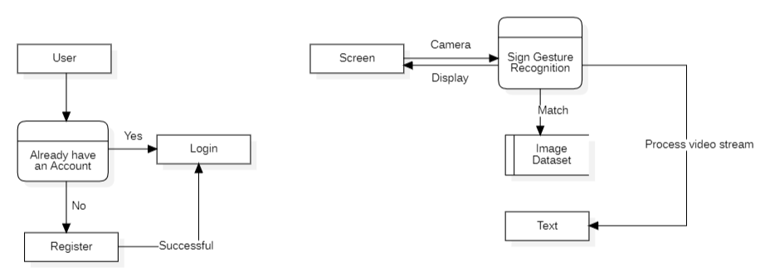

Fig 4.3.3 Level 2 DFD

**4.4 Use case Diagram:**

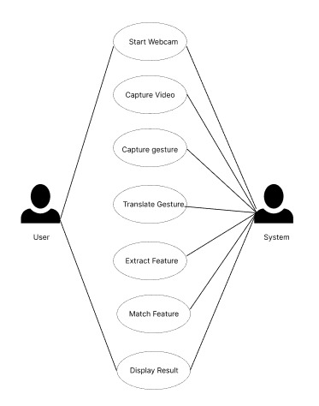

Fig 4.4 Use Case Diagram

**4.5 Sequence Diagram:**

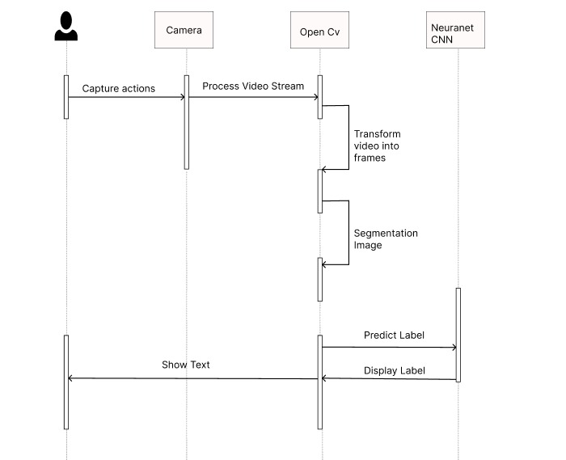

Fig 4.5 Sequence Diagram

# Chapter 5

# Project Planning

# 

Fig 5.1 Gantt Chart

# Chapter 6

# Experimental Setup

**Software Requirements:**

In the Sign Language Detection Website project, the following software and technologies are utilized:

**PHP:** PHP is used for server-side scripting to handle dynamic content and interactions on the website. It may be employed for tasks like user authentication, database connections, and server-side processing of data.

**MySQL:** MySQL is used as a relational database management system to store user data, sign language recognition models, educational resources, and other structured data relevant to the project.

**Flask:** Flask is a micro web framework for Python that can be used for the web development aspect of the project. It can handle routing, serving web pages, and interacting with the back-end components.

**Python (OpenCV, MediaPipe):** Python is a versatile language used for implementing the core sign language detection and interpretation algorithms. OpenCV is utilized for image and video analysis, while MediaPipe provides tools for hand and gesture tracking, both critical components of sign language recognition.

**Visual Studio Code (VS Code):** Visual Studio Code is an integrated development environment (IDE) that can be used for coding, debugging, and testing the project's codebase. It offers features like code suggestions, version control integration, and extensions for various programming languages, making it a valuable tool for the project's development.

**Hardware Requirements:**

The hardware requirements for the Sign Language Detection Website project include:

1. **Web Server:** Utilize a web server like Apache, Nginx, or IIS to host the website.

2. **Processor (CPU):** Use a multi-core CPU with a clock speed of at least 2.5 GHz to handle user requests and real-time interpretation.

3. **Memory (RAM):** Depending on the project scale, allocate 4GB to 16GB or more for efficient operation.

1. **Storage (Hard Drive or SSD):** Employ storage for website files, databases, and recognition models, with an SSD for faster data access.

5. **Graphics Processing Unit (GPU):** For complex AI-based recognition, consider high-end GPUs for accelerated processing.

6. **Network Infrastructure:** Ensure liable network connectivity with ample bandwidth.

7. Webcams and Cameras: Use webcams or cameras with decent resolution and frame rates if video capture is involved.

# Chapter 7

# Implementation Details

**Video Input and Capture:**

**Module Description:** This module handles capturing video input from a camera or webcam, as well as managing the video stream.

**Implementation Technologies:** OpenCV (Open-Source Computer Vision Library) is commonly used to capture, process, and manage video streams. You can use programming languages such as Python or C++ for this module.

**Preprocessing and Image Enhancement:**

**Module Description:** Preprocessing is crucial for enhancing the quality of the video feed, removing noise, and preparing it for analysis.

**Implementation Technologies:** OpenCV and image processing techniques can be used for resizing, denoising, and applying filters to improve the quality of frames.

**Hand Detection and Tracking:**

**Module Description:** This module is responsible for detecting and tracking the user's hand in each frame to isolate it for further analysis.

**Implementation Technologies:** You can use OpenCV and deep learning frameworks like TensorFlow or PyTorch for hand detection and tracking. Hand tracking models such as MediaPipe can also be helpful.

**Sign Gesture Recognition:**

**Module Description:** The sign gesture recognition module identifies and interprets the sign language gestures. It involves training a machine learning or deep learning model on a dataset of sign gestures.

**Implementation Technologies:** Machine learning and deep learning libraries such as scikit-learn, TensorFlow, PyTorch, or pre-trained models like MobileNet and Inception can be used for recognizing sign gestures. Custom models and datasets may be required for your specific sign language.

**User Interface and Output Display:**

**Module Description:** This module handles the user interface, where the recognized sign language gestures are displayed, either as text or sign language animations.

Implementation Technologies: User interfaces can be created using frameworks like PyQt, Tkinter, or web-based interfaces with HTML, CSS, and JavaScript. Animation libraries like CSS animations or JavaScript frameworks (e.g., Three.js) can be used for sign animations.

**Data Storage and Logging:**

**Module Description:** Optionally, you may want to store data related to the detected signs for analysis or future reference.

Implementation Technologies: Databases such as SQLite, MySQL, or NoSQL databases like MongoDB can be used for data storage. Logging libraries in your chosen programming language can handle log records.

**CNN Model:**

**1. 1st Convolution Layer:**

The input picture has resolution of 128x128 pixels. It is first processed in the first convolutional layer using 32 filter weights (3x3 pixels each). This will result in a 126X126 pixel image, one for each Filter-weights.

**2. 1st Pooling Layer :**

The pictures are down sampled using max pooling of 2x2 i.e., we keep the highest value in the 2x2 square of array. Therefore, our picture is down sampled to 63x63 pixels.

**3. 2nd Convolution Layer:**

Now, these 63 x 63 from the output of the first pooling layer is served as an input to the second convolutional layer. It is processed in the second convolutional layer using 32 filter weights (3x3 pixels each). This will result in a 60 x 60-pixel image.

**4. 2nd Pooling Layer:**

The resulting images are down sampled again using max pool of 2x2 and isreduced to 30 x 30 resolution of images.

**5. 1st Densely Connected Layer:**

Now these images are used as an input to a fully connected layer with 128neurons and the output from the second convolutional layer is reshaped to an array of 30x30x32 =28800 values. The input to this layer is an array of28800 values. The output of these layer is fed to the 2nd Densely ConnectedLayer.We are using a dropout layer of value 0.5 to avoid overfitting.6. 2nd Densely Connected Layer :Now the output from the 1st Densely Connected Layer are used as an input to a fully connected layer with 96 neurons.

**6. Final layer:**

The output of the 2nd Densely Connected Layer serves as an input for the final layer which will have the number of neurons as the number of classes we are classifying (alphabets + blank symbol).

# Chapter 8

# Result

Home page mentions key features of website and login button

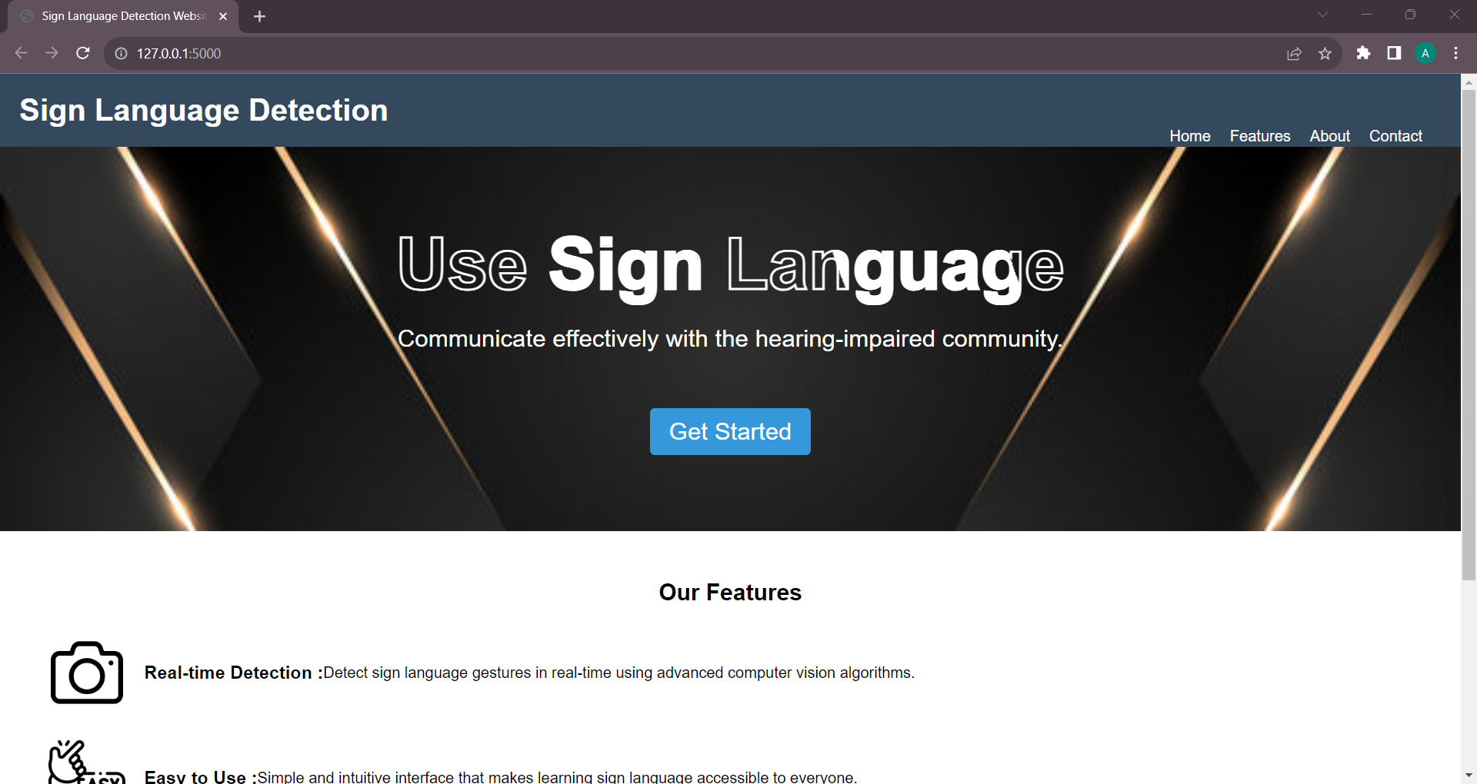

Fig 8.1 Homepage

Login Modal contains option to signup for new users, login with password, login with OTP and forgot password

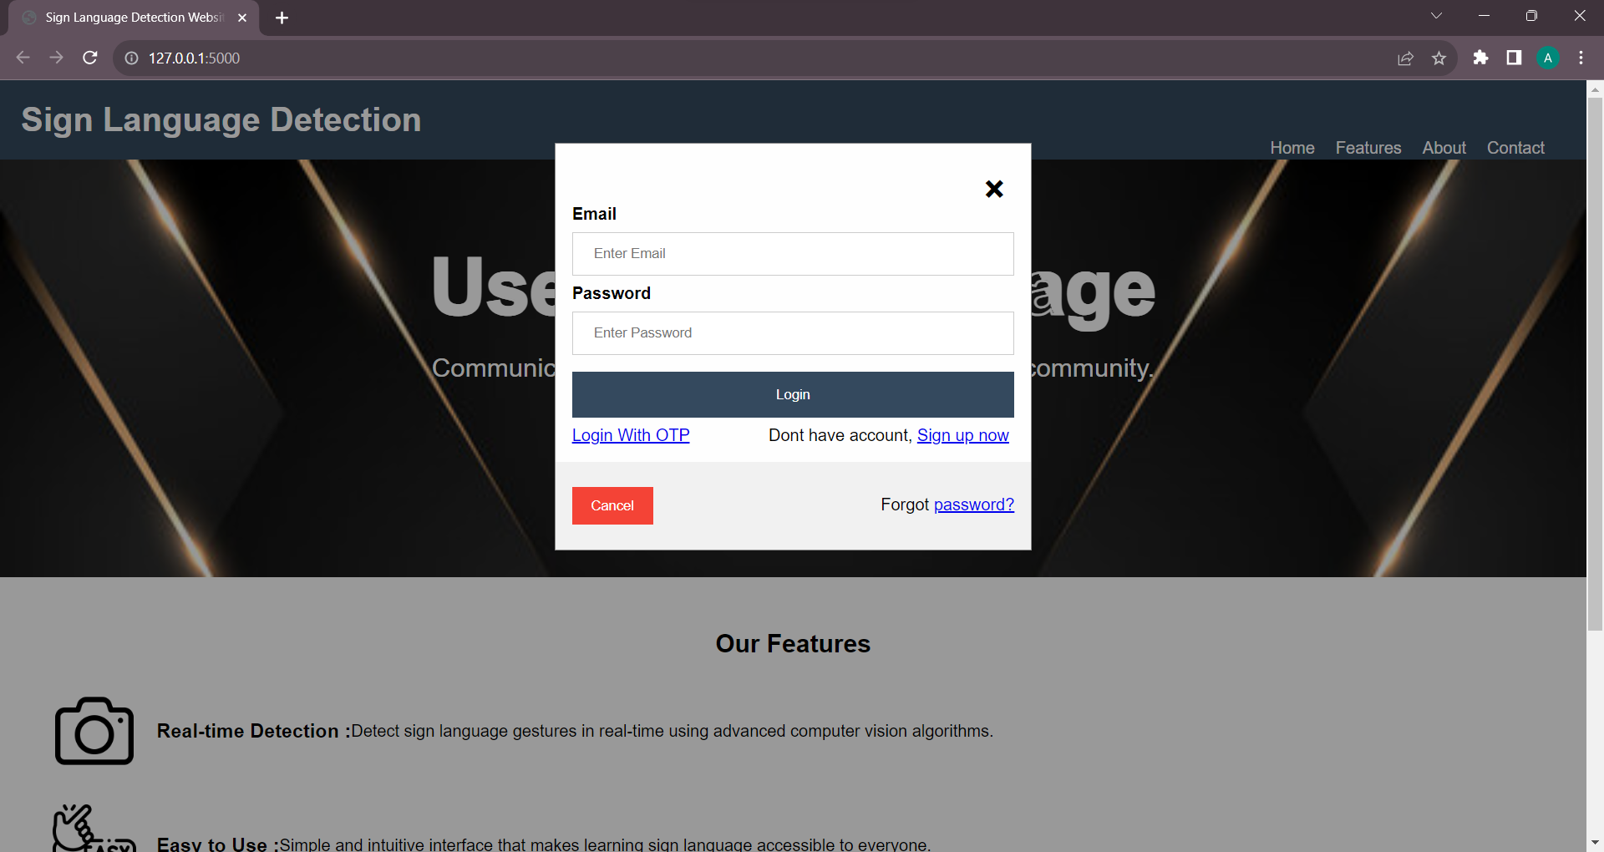

Fig 8.2 Login

User can use editor to make text notes using sign language. The text can be copied to clipboard, saved to user account and can be converted to audio.

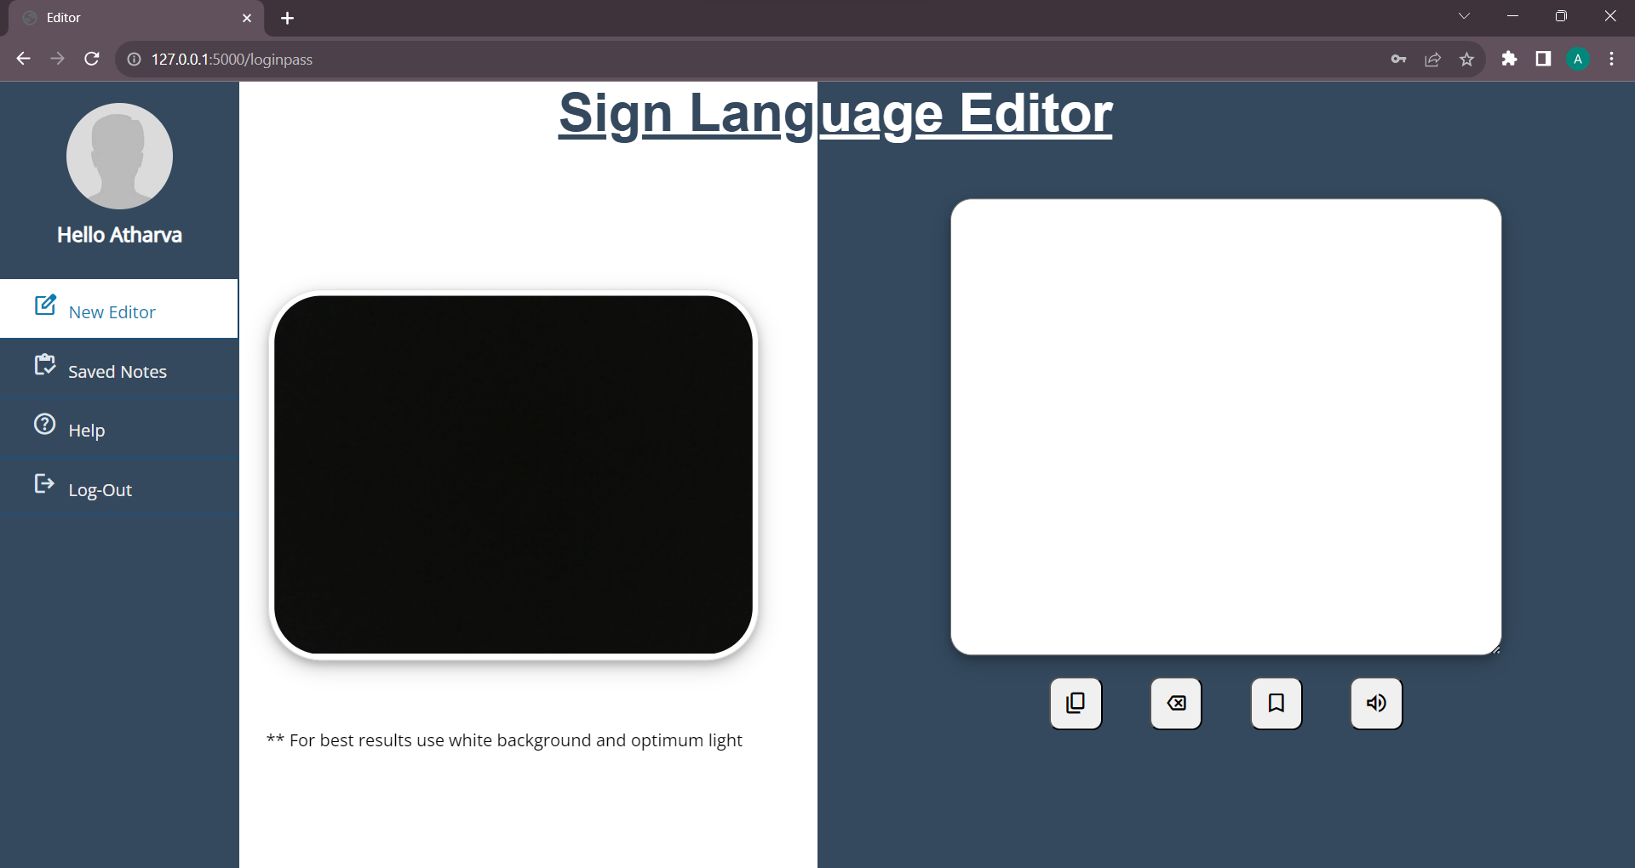

Fig 8.3 editor(a)

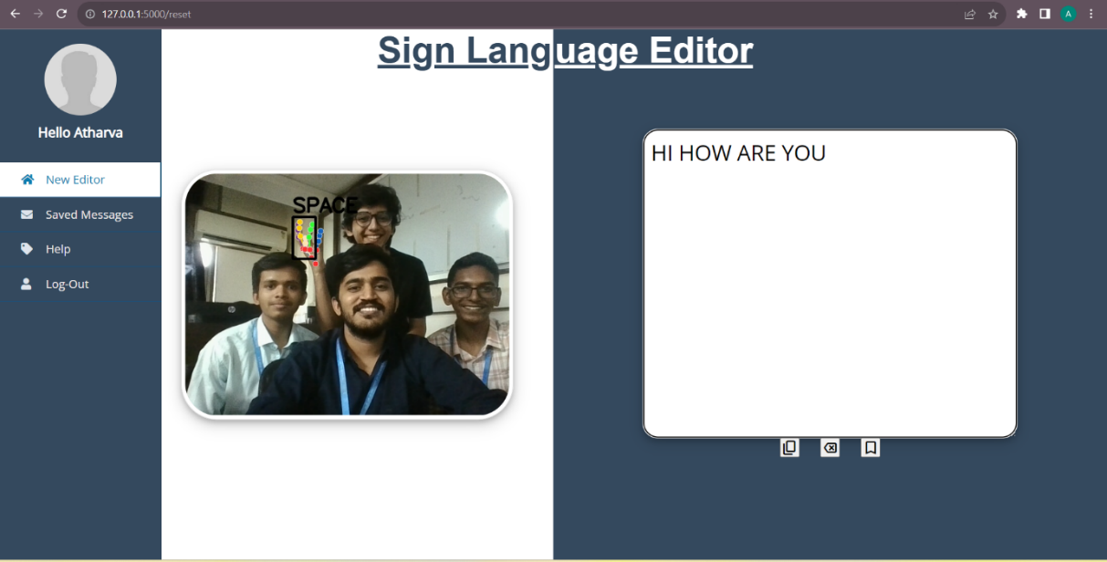

Fig 8.4 editor(b)

Saved notes can be displayed, edited and deleted

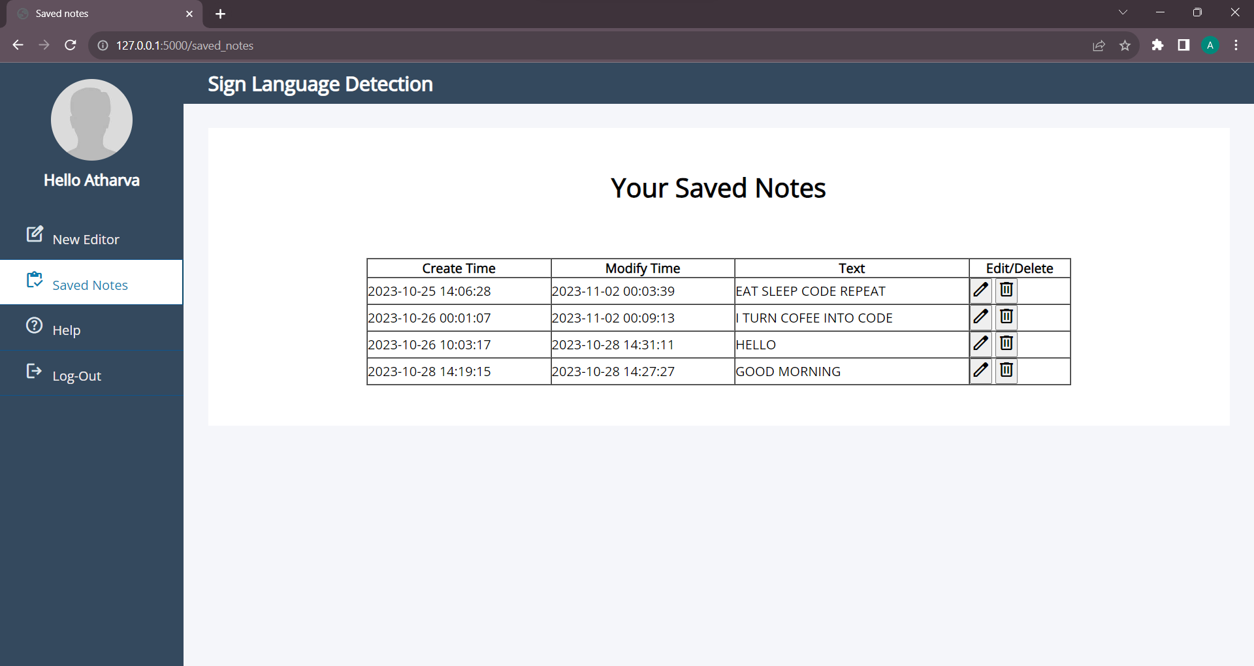

Fig 8.5 saved notes

# Chapter 9

# Conclusion

In creating the Sign Language Detection Website, we embark on a transformative journey to redefine the way we communicate, understand, and connect. This project holds the promise of making a profound impact on the lives of individuals who use sign language as their primary means of expression and those who seek to engage with them.

By offering real-time sign language interpretation, the website is poised to facilitate communication in a way that is natural, inclusive, and immediate. The user-friendly interface, adaptability, and customization options ensure that the website is accessible and tailored to the unique preferences of individual users. Educational resources support both learners and experts, promoting a deeper understanding of sign language's grammar and cultural context.

The commitment to accessibility and security underscores our dedication to user privacy and inclusion. The feedback mechanism invites user participation, allowing us to refine and enhance the website continuously based on user input. Integration possibilities open doors to wider applications, bridging the communication gap across multiple platforms and contexts.

Community building features and collaboration with sign language experts strengthen the project's social fabric, fostering a sense of belonging and mutual support. The ongoing research and development aspect ensures that the website remains at the forefront of technological advancements, consistently improving accuracy and user experience.

In conclusion, the Sign Language Detection Website Project represents a journey toward breaking down communication barriers, fostering inclusivity, and empowering all individuals, regardless of their hearing ability. It signifies a commitment to creating a world where communication knows no boundaries and where the rich tapestry of sign language can be shared, celebrated, and understood by all. Through this project, we take a significant step toward making this vision a reality.

# References

[1] Smith, J.A., Johnson, E.R. (2021). "Sign Language Recognition Using Deep Learning: A Review." IEEE Transactions on Neural Networks.

[2] Adams, S.E., Lee, D.C. (2021). "Real-time Sign Language Detection and Translation: A Machine Learning Approach." ACM Transactions on Accessible Computing.

[3] Clark, R.M., Garcia, R.L. (2021). "Adaptive Sign Language Detection for Multiple Dialects." International Conference on Computer Vision.

[4] Patel, L.K., Brown, M.J. (2021). "Towards Universal Sign Language Recognition: Challenges and Prospects." IEEE Transactions on Human-Machine Systems.

[5] Harris, R.A., Mitchell, J.L. (2022). "Deep Learning-Based Sign Language Interpretation: Recent Advances and Future Directions." Pattern Recognition.

[6] Turner, J.A., Anderson, W.J. (2021). "Accessibility Technology for Deaf and Hard-of-Hearing Individuals: A Review of Recent Developments." IEEE Transactions on Accessibility.

[7] Rodriguez, M.S., Martinez, C.M. (2022). "Sign Language Translation and Its Role in Communication Accessibility." Journal of Ambient Intelligence and Humanized Computing.

[8] Kim, H., Lee, S. (2021). "Sign Language Detection in Video Sequences using Deep Learning." Sensors.

[9] Garcia, A.L., Wang, X. (2022). "Real-Time American Sign Language Recognition and Translation: A Review." IEEE Transactions on Artificial Intelligence.

[10] Choudhury, S., Das, A.K. (2022). "Enhancing Sign Language Recognition through Sign-Specific Gestural Features." Information Sciences.

[11] Zhang, Q., Li, Y. (2021). "Dynamic Hand Gesture Recognition and Sign Language Interpretation Using LSTM." Expert Systems with Applications.

[12] Alves, J., Santos, C. (2021). "Sign Language Recognition in Different Lighting Conditions: A Comparative Study." Journal of Visual Communication and Image Representation.

[13] Sarker, S., Akhtar, S. (2022). "Sign Language Recognition and Translation in Mobile Devices." Mobile Networks and Applications.